Bridge Kit

| **Subject:**  **Related Subjects:** | **Grade Level(s):**  **Length of Lesson:** | **Type:** Inquiry / Design / Project  **Keywords:** |
| --- | --- | --- |

# Lesson Overview

Students will use math and Science to implement engineering concepts in the design and construction of a model bridge from their own plans that will carry a maximum load while using as few craft sticks as possible; stressing neatness, craftsmanship, and creativity. In this activity, students will use craft sticks and Velcro to understand the principles involved and to test various designs. Pictures of different bridges have been provided at the end of this activity.

# Lesson Focus

*What is the central question or phenomenon being investigated? What problem are they trying to solve?*

| Lesson Objective(s) | **Objectives:** Use math and science to understand engineering concepts and to build skills.Design and construct a model bridge that will carry a maximum load while using as few materials as possible, stressing neatness, craftsmanship, and creativity. |
| --- | --- |

# Lesson Timing

| 5 minutes | Introduce the Lesson |
| --- | --- |
| 30 minutes | ... |
|  |  |
|  |  |

| Materials | **Activity-1**  20 Straws  Masking Tape  **Activity-2**  10 plastic straws  35 – Hex nuts  1 – Ruler  1 Pair of scissors  1 small paper cup 3 oz.  **Activity-3**  100 Toothpicks  Hot Glue  3 oz cup  Hex Nuts  2 blocks  **Activity-4**   1. Only solid untreated natural wood craftsticks (e.g. popsicle sticks) 2. Maximum number of sticks allowed, including partial sticks, is **50**. Each piece of stick, regardless of size, will be counted as one structural member. 3. Velcro must be used to attach pieces. |
| --- | --- |
| Instructor Prep | 1. Step 1 |
| Related Resources | * List related lessons/ppts etc available from USC or outside, trusted orgs |

# Lesson Plan

## Introduction

**Concepts to Consider**

| **Stress and Strain**  When a force is applied to an object with either a pushing or pulling motion, the object is being stressed. For example if a spring is pulled apart it changes shape. This change of shape is called strain. | **Force Lines**  When a load is placed upon an object, lines of force occur. These lines of force are carried through all parts of the object towards the ground. | **Elasticity**  Just like a rubber band returns to its original shape, most materials do the same thing. When a material is stressed and it returns to its original shape it is showing the property of elasticity. |
| --- | --- | --- |
|  |  |  |

**Types of Stress**

|  | | | | |
| --- | --- | --- | --- | --- |
| **Compression** | **Tension** | **Bending** | **Torsion** | **Shearing** |

**Results of Tension and Compression Testing**

***Tensile strength*** depends on: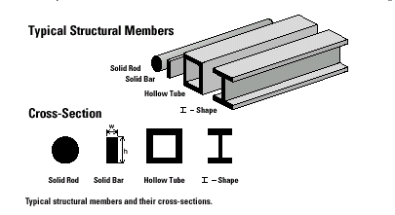

* Type of material
* Thickness of cross-section
* Width of cross-section

Tensile strength does not depend on:

* Length of member
* Shape of cross section.

***Compressive strength*** depends on: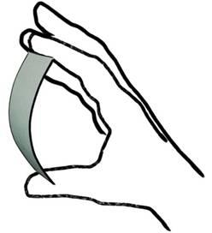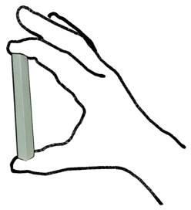

* Type of material
* Length of member
* Width and thickness of cross-section
* Shape of cross-section

## 

## Procedure

**Activity 1: Forces that Effect Structure**

**Triangle vs. Square**

**Directions:**

Which structure is stronger triangle or square?

Part I

1. Tape the four straws and tape together to form a square.
2. Tape three straws together to form a triangle.
3. Apply pressure to corners. Which object this stronger? Why?

Part II-3D

1. Tape straws together to form triangular prism
2. Tape straws together to form rectangular prism
3. Apply pressure to top. Which object is stronger? Why?

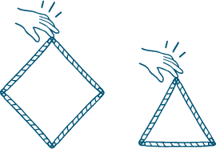

**Activity 2 – Understanding Types of Forces of Stress**

**Design Constraints:**

1. Bridge must be no shorter than 10 inches and no longer than 12 inches.
2. The two sides of bridge must be identical.
3. Top of bridge you will use sticks going vertically connecting both sides.

**Define the Problem**:

1. Create a bridge using the design constraints to construct a bridge which can carry the heaviest load.

**Plan/Brainstorm:**

1. How many truss triangles should it have?
2. What supports are needed and where?

**Design:**

1. Using the truss triangle shape draw your bridge design on graph paper..
2. Each straw should be 2 inches long for vertical and horizontal sides and 2.5 inches long for diagonal sides. Each graph square on paper is .5 inch is .5 inch.
3. Place wax paper on top of your design.

**Build:**

1. Tape straws together to form each two sides of the bridge design.
2. Remember to create two identical sides for your bridge.
3. Hold up two sides 2.5 inches apart and tape straws vertically to form a top and a bottom for the bridge to support each side.
4. Place paper cup inside center of bridge and put hex nuts in cup. Count how many you can place in cup until bridge collapses.
5. How many nuts were in cup?
6. Why did bridge collapse?
7. How could you build it better next time?

**Activity 2a:**

**Bridge Extension Lesson Idea for High School:**

1. Have students analyze what would happen if a bridge on freeway 10 collapsed due to a rainstorm. It was 48 years old and had just rated an A on construction. How would you design and rebuild it? You need more durable material. What type of materials would you use? What are your design constraints? Research what materials were used, traffic, around bridge, etc. You can only spend $50,000. To repair it.

**Activity 2b:**

**Bridge Lesson Extension Idea for High School:**

1. Have students use a real topographic map of area in Nicaragua and build a bridge to go over the river or gorge. Have them research the challenges to build a bridge. Have students look at design constraints when constructing the bridge (cost, resources, weather, traffic, weight on bridge, materials, etc.) 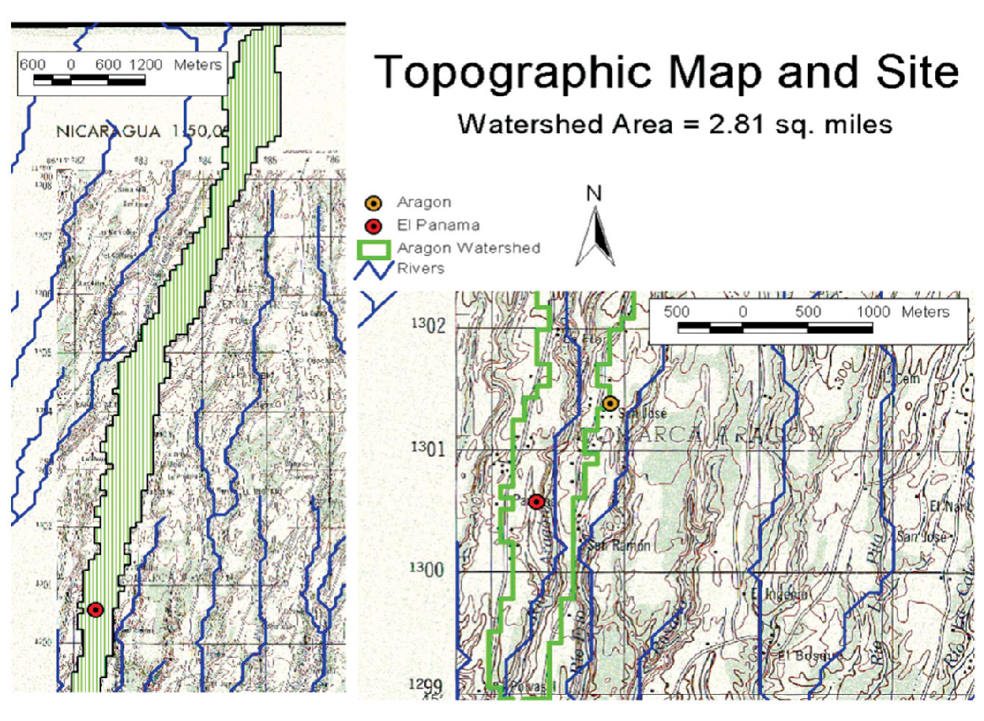
2. **Activity 2c. Bridge Building Lesson Plan Extension Middle School**

**Bridge Tower Challenge**

**Problem**: In a suspension bridge, the middle supports are called towers. Long steel cables are strung over towers and secured to anchors at both ends of the bridge. Your city has decided to construct a suspension bridge across a large lake that is almost one mile wide. They must construct a bridge that will span the width of the lake, support the weight of the cars that will travel across the bridge and not shift or twist.

**The Challenge**: A representative from the city has contacted you to design a model of a bridge tower that will support the length and load of the suspension bridge.

**The Materials**: You will use spaghetti noodles to represent the beams that will be secured to the foundation of the bridge, a milk carton to represent the top of the tower where the cable will be attached, and masking tape. You may use no more than 100 spaghetti noodles and 2 straws. You may only use the tape to secure the spaghetti noodles to the can.

**The Cost:**

Beams (spaghetti noodles) =$500 each

Support beams (straws)=$1,500.00 each

Securing rods (masking tape) = 300/inch

Tower (milk carton)=$10,000

**Brainstorm, Pick Best Design and Build !**

**Activity 3 – Build and Test Toothpick Bridges**

**Directions:**

1. **Create 4 Identical Bridges**

Using hot glue, create 4 identical toothpick bridges using the following dimensions and restrictions. Be careful when using hot glue and use only a tiny amount.

* Width 2”
* Length 6”
* No more than ½” of an end of a toothpick maybe glued to another toothpick. However a toothpick may have toothpicks glue to both sides



1. **Add Arches to 3 Bridges**

Use additional toothpicks and hot glue to add arches both sides of 3 bridges.











1. **Add Struts to Top of Arches to 2 Bridges**

Choose 2 bridges with arches, and using additional toothpicks and hot glue add struts from one side of bridge to the other (from arch to arch). Leave enough room for the 3 oz cup to fit between the top of the two arches.











1. **Add Vertical Supports to 1 Bridge**

Choosing one bridge with arches and struts, add vertical supports for bridge. Leave enough room for the 3 oz cup to fit between the two arches.













1. **Testing**
2. Place blocks 5.5” apart
3. Place empty 3 oz cup on each bridge and add hex nuts to cups until bridge collapses

| Bridge | Roadway only | Triangle Arches | Cross struts | Vertical supports |
| --- | --- | --- | --- | --- |
| # Hex nuts |  |  |  |  |

1. **Questions**

**Which bridge held the most hex nuts? Why? What forces come into play? Which direction do the forces flow?**

**Activity 4: Build and Test a Craft Stick Bridge**

**Note: *Rules for this activity are NOT the same as for the actual MESA Day event.*** Please see MESA Day Contest Rules for Stick Together for the actual rules.

**Testing apparatus:**

|  |  |
| --- | --- |
| Sand (not provided) | Bucket (provided) |

|  |  |  |
| --- | --- | --- |

**Rules for Bridge Size:**

1. 1. Maximum horizontal length: 12 inches
2. 2. Maximum width: 5 inches
3. 3. Maximum height above top of roadway: 7 inches
4. 4. Maximum depth below top of roadway: 3.5 inches
5. 5. Minimum horizontal length: 10 inches
6. 6. Minimum width at every point: 4 inches
7. 7. Minimum width of open roadway: 3.5 inches (running entire length of bridge)

**RULES FOR CONSTRUCTION:**

* A maximum of 50% of a craftstick’s total flat surface may be Velcro’d. Both sides of each stick can be considered in the 50% calculation. e.g. 100% of side 1 and 0% of side 2; 75% of side 1 and 25% of side 2.
* Velcro must only be used at joints, and must not be used on the surface of the roadway.
* No coatings of any kind, including glue, paint, cement, epoxy; etc. may be applied to any surface of the bridge. The Bridge will be disqualified if it is coated with any substance.
* The bridge must be open at the top to allow insertion of testing apparatus.
* Bridge must have 1cm gap in the center to accommodate testing apparatus (This is only for the classroom testing apparatus and will not be the case in the actual competition).
* I-beams are illegal.
* The bridge must have a clear and unobstructed roadway at least 3 ½ inches wide, running the full length of the bridge, as if automobile traffic were going to cross it. The roadway shall be considered a roadway if a toy model car or truck freely rolls from one end to the other. The toy car/truck can be provided by the entrant. If a car is not provided by the entrant, a standard “Hot Wheels” or “Matchbox” car will be used.
* The bridge may not have a roof, covering or any other object that will interfere with the 3½ x 3½ test plate that is placed directly on roadway at midspan to apply the force for load bearing capacity.
* T-sections and longitudinal Velcro may be used on the roadway only.
* The bridge must rest on the tester support blocks in a stable manner, i.e. bridge substructure may NOT interfere with testing apparatus.
* Rules for this activity are **NOT** the same as for the actual MESA Day event. Please see MESA Day Contest Rules for Stick Together for the actual rules.

|  |  |  |
| --- | --- | --- |
|  |  |  |
|  |  |  |

**Craft Stick Bridge Kit Debrief**

How were compression, tension and superstructure demonstrated in the kit?

_____________________________________________________________________________________

_____________________________________________________________________________________

_____________________________________________________________________________________

_____________________________________________________________________________________

How are the activities in the Craft Stick Bridge kit different from the actual Craft Stick Bridge Competition?

1. ______________________________________________________________________________
2. ______________________________________________________________________________
3. ______________________________________________________________________________
4. ______________________________________________________________________________
5. ______________________________________________________________________________

How will you relate the concepts you learned from the kit to the Craft Stick Bridge competition?

I will ________________________________________________________________________________

I will ________________________________________________________________________________

I will ________________________________________________________________________________

I will ________________________________________________________________________________

I will ________________________________________________________________________________

Based on what you have learned, what are some challenges you’ll have to overcome for a successful Craft Stick Bridge?

_____________________________________________________________________________________

_____________________________________________________________________________________

_____________________________________________________________________________________

_____________________________________________________________________________________

## Wrap-up

*End the lesson with some final discussions about what students designed/discovered. Connect their activity back to the focus question/problem, real world examples, and STEM careers.*

*Also include notes about any special cleanup considerations*

# Lesson Background for Teachers

## Suggested Real-World STEM Connections

* List possible related Role Models in STEM (with details and links to more reading). Give suggestions for examples of scientists/engineers who are from underrepresented groups in STEM in related careers.
* List related real-world engineering problems and examples

## Lesson Variations and Options

Include descriptions of alternative methods or ways to present things.

## Explanation

*Describe the background concepts and explanations behind the lesson. This can be more in depth than a teacher/instructor would actually share with students.*

## Key Concepts and Vocabulary

**Bridge Vocabulary**

The following words are used in basic bridge building. Students should research these words and become familiar with them.

* Superstructure
* Substructure
* Compression
* Tension
* Shear
* Torsion
* Bending
* Abutment
* Arch
* Critical load
* Live load
* Strut
* Suspension
* Torque
* Strut
* Chord
* Vertical

## Safety Notes

* Safety instruction